Introduction of Master Chef Raj’
M RAM DEWASI (RAJ MAHARAJ) My Business Profile & Activities
  - Hotels & Catering Industry’s

Chef Raj is originating from India since1988, that aims to discover culinary talent on International and national level through a series of cooking challenges critics professional culinary skills, creativity, and presentation.
Key aspects of Master Chef Raj’ presentation:
- Visual Appeal: Dishes on MasterChef are expected to be visually stunning, with a strong emphasis on food plating and presentation that enhances the dining experience. Judges often evaluate the aesthetic appeal of a dish alongside its taste.
- Technique & Innovation: Contestants are encouraged to use innovative techniques and demonstrate their mastery of cooking methods to create memorable and impactful plates.
- Elements of Presentation: Successful presentations often incorporate elements like balance, colour, composition, and thoughtful arrangement of ingredients to create a harmonious and appealing final dish.
- Examples from the Show: Videos from the show highlight specific presentations that impressed judges, showcasing dishes with unique elements like hazelnut snow, seared and smoked venison, or perfectly caramelized scallops.
- Tips for Improvement: Master Chef suggests avoiding inconsistent portion sizes and focusing on principles of balance, colour and composition to elevate home-cooking to a "MasterChef" level.

Master Chef Presentation!
Chef Raj is a popular in 60 countries worldwide. He is professional chefs competing in a variety of challenges to showcase their culinary skills and creativity. With its emphasis on high-quality ingredients, innovative techniques, and expert judgment, MasterChef has become a cultural phenomenon and a source of inspiration for aspiring chefs around the world. Chef Raj’ template showcase his culinary skill related content in a visually engaging way, his presenting on cooking techniques, recipes, or food culture.
Presentation on the international level, Chef Raj role in the hotel business and catering industry would encompass culinary operations, food and beverage service management, and the broader impact of these services on a hotel's success and a region's culture. It would detail the multifaceted responsibilities of chefs, from food preparation and presentation to menu planning, and highlight how these elements contribute to a positive guest experience and profitability.

Key aspects of such a presentation would include:
- Role of the Master Chef Raj ‘on International Level: Emphasize the chef's expertise in diverse cuisines, their ability to attract international clientele, and their contribution to the hotel's reputation and brand.
- Culinary Operations: Detail the organization and operations of the kitchen, including food production, cooking techniques, quality control, and adherence to hygiene standards.
- Food & Beverage (F&B) Management: Explain the management of F&B services, covering areas like menu planning, inventory, cost control, staffing, and customer service in dining and banquet settings.
- Catering Services: Explore the various catering services offered by hotels, including event catering, banquets, room service, and specialized dining experiences.
- Impact on Hotel Business: Discuss how a skilled international chef and efficient F&B operations enhance customer satisfaction, drive revenue, and contribute to the overall success of the hotel.
- Industry Trends: Briefly touch upon emerging trends in the hospitality and catering industry, such as sustainable sourcing, fusion cuisine, and technology in kitchen management.

Culinary operations in a hotel, & global catering service.
Culinary operations in a hotel involve a wide range of activities related to food preparation, cooking, and presentation. The goal is to provide high-quality meals and dining experiences for hotel guests. Here are key aspects of culinary operations in a hotel:
- Menu Planning: Culinary operations begin with menu planning. This involves creating a diverse and appealing menu that caters to the preferences of the hotel's target clientele. Menus may include options for breakfast, lunch, dinner, room service, banquets, and special events.
- Kitchen Organization: The kitchen is typically organized into different sections, such as the hot kitchen, cold kitchen, pastry section, and sometimes specialized sections like a sushi bar or grill station. Each section is responsible for specific types of dishes or culinary techniques.
- Food Procurement: Procuring high-quality ingredients is crucial. This involves establishing relationships with suppliers, ensuring the freshness of ingredients, and managing inventory.
- Food Preparation: Chefs and kitchen staff prepare dishes according to standardized recipes. Attention to detail and consistency are key to maintaining the quality of the food.
- Cooking Techniques: Culinary operations in hotels often involve a variety of cooking techniques, ranging from grilling and sautéing to baking and sous vide. Chefs may need to accommodate various dietary restrictions and preferences.
- Hygiene and Food Safety: Adherence to strict hygiene and food safety standards is essential. This includes proper handling, storage, and cooking of food to prevent contamination.
- Staff Training: Training kitchen staff is crucial for maintaining consistent quality. This includes teaching culinary techniques, safety protocols, and customer service skills.
- Special Events and Catering: Hotels often host special events, banquets, and catering services. Culinary teams need to be versatile and capable of handling a variety of events and menu styles.
- Presentation: The presentation of dishes is as important as their taste. Culinary teams focus on creating visually appealing plates that enhance the overall dining experience.
- Waste Management: Efficient use of ingredients and minimizing food waste is an important consideration. This involves proper portion control, inventory management, and recycling practices.
- Collaboration with Other Departments: The culinary department collaborates with other hotel departments, such as the front desk and marketing, to ensure a seamless dining experience for guests.
- Adaptability: Culinary teams must be adaptable to changing trends, guest preferences, and dietary requirements. Staying current with food trends and incorporating them into the menu can enhance the hotel's culinary offerings.
In summary, successful culinary operations in a hotel require careful planning, skilled execution, attention to detail, and a commitment to providing a memorable dining experience for guests. The culinary team plays a crucial role in shaping the overall reputation and success of the hotel.
Associated International Travel Industry Catering Starts From 2007 Continue Running Manage
  - Cox & Kings Limited, Mumbai (CLOSE COMPANY)
  - Thomas Cook Tours Travels India Ltd Mumbai
  - SOTC Travels & Tours PVT LTD Mumbai
  - Club 7 Holidays, Pvt Ltd Mumbai
  - FCM Travel, PVT LTD New Delhi
  - Orbit Tours & Travels, Mumbai
  - In Orbit Tours & Travels, Mumbai
  - Guideline Tours & Travels, Mumbai
  - My Holiday Tours & Travels, Mumbai
  - Comfort Voyages Mumbai
  - Shree Krishna Tours & travels Mumbai
  - Red Carpet Tours & Travels New Delhi
  - B&Z Luxury Holiday, Andheri W Mumbai
  - Bests Voyages in Ahmadabad Gujarat
  - Shah Tours Virle Parle Mumbai
  - Akquasun Groups Andheri Mumbai
Flamingo Travels Ahmedabad
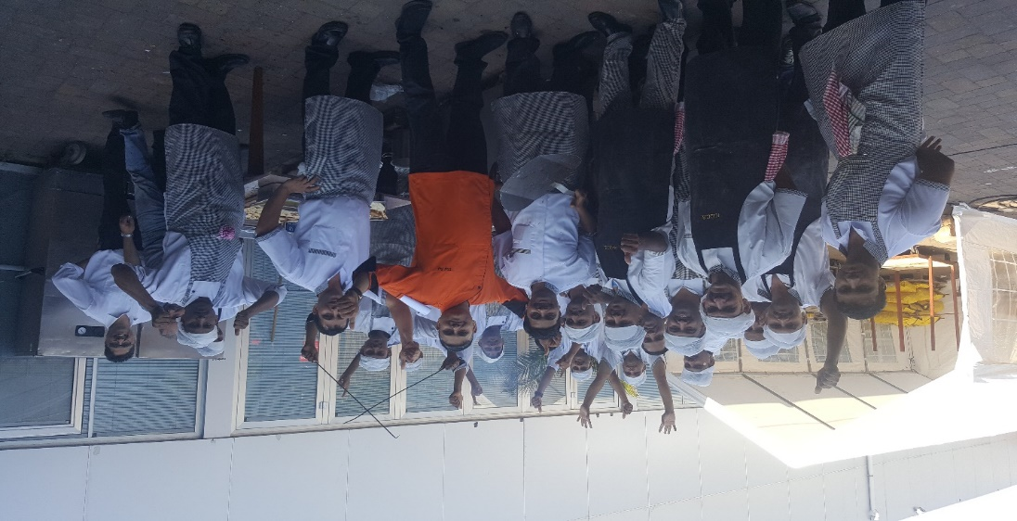
Amsterdam Netherlands Exide Battery Events 2017
International Corporate Events Conducted 2007 To 2020
• ICICI Prudential Life Insurance Jan 2017‐450 Pax, in Chiang Mai, Thailand (Cox & King)
• OTTO Co. Feb 2017 –280 Pax, in Sydney, Australia (Cox & King)
• Cipla Pharmaceutical Mar 2017 –90 Pax, in Japan (Comfort Voyages Mumbai)
• Ambuja Cement April & May 2017 450 Pax in Cape Town, South Africa (Fountain Head Pvt Ltd Mumbai)
• Berger Paint May 2017 –700 Pax, in Berlin & Prague, Europe (Thomas Cook)
• Bajaj Allianz Aug 2017,320 Pax in Prague CZ (Thomas Cook)
• Jain Social Group June & July 2017 400 Pax in Scandinavia & Russia (Comfort Holidays)
• Exide Battery Event 2017, 1500 Pax, in Amsterdam, Netherland FCM Travel, India’s Biggest Event in Europe
• Destination Wedding June 2017‐800 Pax, in Mauritius (Divas & CCI Delhi)
• Bhagwat Katha July 2017 –400 Pax, in Mauritius (Cox & King)
• Siyaram’s Suiting & Shirting 330 Pax,in Sydney & Melbourne, Australia, Guideline Travels August2017
• Ultratech Cements 900 Pax in South Africa, Singapore & Star Cruises Hong Kong, Macau, With Club 7 Holidays,2009,2011,2014
• Ultratech Cements 800 Pax in Austria & Italy,2016 Sotc
• Birla Sun Life Insurance ‐300 & 500 Pax in Vietnam, & South Africa 2012, 2013 In Orbit Travel
• Wedding With (Comfort Event Voyages Mumbai) 2012/2014/2016 Hotel Lalit Goa
• Wedding With (Comfort Event Voyages Mumbai)2014/2015 Hotel ITC Maratha & Grand Mumbai
• Torrent Pharmaceuticals ‐750,1200 Pax in Cyprus, Jordan, Egypt 2008, 2010, 2011 In Orbit Travel
• Syntex Ltd ‐350 Pax in Egypt 2007 Orbit Travel
• Anchor Limited ‐850 Pax in South Africa 2009 My Holiday Vile Parle Mumbai
• Siyaram Suitings‐400 & 700 Pax in Malaysia Indonesia Thailand Oman 2010, 2011, 2012, 2013, 2014, 2017 Guideline Travels)
• Ajmera Builders ‐200 Pax in China, South Africa, New Zealand, Russia 2010,2012,2014,2016
• Donear Suiting & Shirting‐300 Pax in Malaysia, Indonesia 2013 (Guideline Travels)
• Yes Fabrics ‐ 300 Pax in Manila Philippines 2013 (Guideline Travels)
• Everest Masala ‐350 Pax in Dubai, China 2010 (Comfort Voyages Mumbai)
• Arun & Sons Diamond Merchants)155 Pax in Russia & Scandinavian Countries 2014, (Comfort Voyages Mumbai)
• Gold medal Electrical Switches Systems‐350,400,750,400 Pax in Australia 2015 World Cup
Switzerland Dubai Thailand 2014, 2015, 2016,2018 B&Z Luxury Holiday Andheri W
• Jain Social Group ‐250 to 350 Pax New Zealand, Australia, China, Canada
Russia Scandinavian 2012,2013,2014,2015, 2016, 2017 (Comfort Voyages Mumbai)
• Trade Fairs: K 2010, K 2013 2016 in Germany ‐350, 575, 750 Pax (Cox And Kings)
• Trade Fairs: CPHI Madrid 2009 2010,2011,2012,2013 Germany, Spain & France 350 Pax (TMIC) Mumbai)
• Indian Paints Association Group ‐500 Pax in Thailand 2010 (BEST HOLIDAY NEW DELHI)
• Kapol Social Group 200 Pax in Australia, New Zealand & China 2012 2013, 2014 (Comfort Voyages Mumbai)
• Poddar Family Wedding & Tanna Family 700 Pax in Sunway Lagoon Resort Malaysia 2014 & 2016 (Guideline Travels)
• Propkar UtsavYatra2015 ‐375 Pax in China & Canada & USA Russia 2014,2015,2016,2017 (Cox And Kings)
• Orient Electric CK Birla 350 Pax in Madrid Spain Milan Italy New Zealand 2016, 2017,2018, (Cox And Kings)
• Asian Paints Company 1200 Pax In Austria & Budapest 2018 Sotc
• Sun Pharma Groups 3500 Pax In Turkey Istanbul 2018 With Akquasun Group Company
• Ultratech Cements 800 Pax In Russia 2018 With (Cox And Kings)
• Soktas Fabric 90 Pax In Turkey 2018 B&Z Luxury Holiday Andheri W
• (Cox And Kings) & (Shah Tour) Group 750 Pax In Turkey 2018 Family Tour
• (Cox And Kings) 12000 Pax In UK London Duniya Dekho Series 2018
• Wedding 400 Pax Group In Bintan Indonesia ARK Tours Travel Andheri December 2018
• South Africa 560 Pax Family Group (Guideline Travels) & Shah Tour Travel
• Great White Electricals Pvt Ltd (NCL Cruise) Denmark 300, Pax Group 2019 Cox And Kings
• Jain Social Group Comfort Voyages Mumbai175 Pax China,200, Turkey,150, Europe 2019
• Luxury Group 500, Pax In Turkey,100 Pax, South Africa Shah Tour Mumbai 2019
• Luxury Group 200, Pax In Turkey Flamingo Travels Ahmedabad 2019
• India First Life Insurance Fountainhead Travels Mumbai Paris France 2019
• Orient Electricals 350 Pax Group Rome Thomas Cook 2019
• Vivo Phone 155 Pax Group Baku Azerbaijan Global World Travel Kandivali (W) Mumbai 2019
• Luxury Group 200,120,140, Pax Thailand, Europe, Vietnam B & Z Luxury Holiday Andheri W 2019
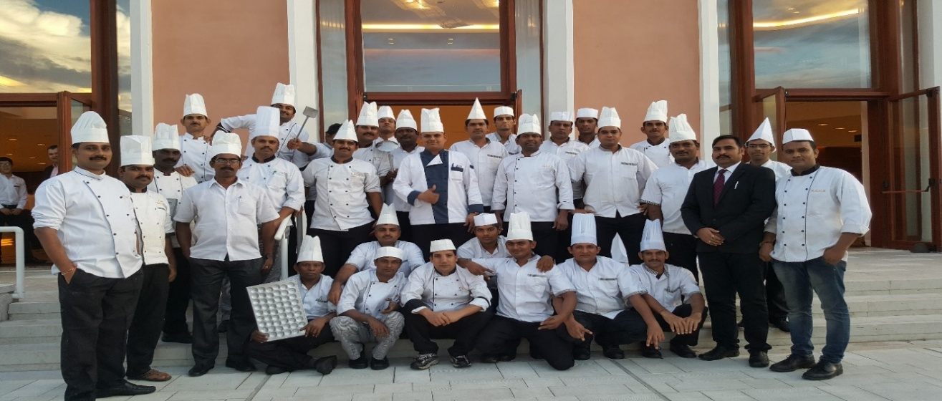
Ultratech Cement Events 2016 JW Marriott in Venice
• B&Z Luxury World Gold Medal‐200, Thailand and Spain 70. Pax 2022
• Stoc Travel Mumbai Asian Paints Company 200 Pax in Sweden & Denmark 2022 Stoc
• 120, Pax Luxury Group in Turkey Flamingo Travels Ahmedabad 2022
• 100, Pax Luxury Group in Turkey And 100 Pax, 270, Pax Leh Ladakh South Africa Shah Tour Mumbai 2022.

• Comfort Voyages Mumbai Ajmera Family Group 175 Pax Prague, Vienna Budapest, Europe Aug 2022

• Head Event Pvt Ltd Dadar Mumbai Icici Prudential Insurance Moving 450 Pax Aug 2022

• B&Z Luxury World Andheri Mumbai Gold Medal Electric Group 2250 Pax Thailand Oct 2022

• B&Z Luxury Holiday Andheri Mumbai Gold Medal Electric Group 290 Pax Australia Nov 2022
• Flamingo Travels Ahmedabad Diwali Special Group 385 Pax in Turkey Nov 2022
• Shah Travels Diwali Special Group 275 Pax in Vietnam Nov 2022
• Shah Travels Mumbai Diwali Special Group 165 Pax in South Africa Nov 2022
• SOTC TRAVEL COMPANY Berger Paints at Australia and New Zealand 1360 Pax May 2023
• Akbar Holidays Mumbai Ultratech Cement UK 1040 Pax Group Sep 2023
• Indus Tour Company New Delhi 150.Pax Group China Trade Fair at April 2023,
• Anthem Tour Company New Delhi 120.Pax Group China Trade fair at May 2023,
• Urvi Tour Mumbai Company Mumbai 110.Pax Group Turkey at May 2023,
• Gold Medal -2200 Pax at Dubai Group Travel B&Z Tour ANDHERI WAEST
• 1800 Pax Japan, Turkey, Vietnam Europe, Sri Lanka Laser Group with Feb to Dec 2023 Flamingo Travel Company
• Guideline Travel Mumbai Wedding Group 800 Pax at Thailand May 2023
• Guideline Travel July Arvind Fabric Group 1400 Pax at Vietnam 2023
• Shah Holidays Laser Group 1200 Pax Group Nepal, South Africa, Turkey, Vietnam, Baku Japan Jan to Dec 2023
• FCM Tour Company Mumbai 430.Pax Group Bali at Jan 2024,
• Urvi Tour Mumbai Company Mumbai 220.Pax Group New Zealand at Feb To May 2024,
• B&Z Tour Luxury Andheri West 460, Pax Group Thailand April 2024,135, Pax Budapest Aug
• Flamingo Travel Company2600 Pax Aus New Zealand, Japan, Turkey, Vietnam, Baku Europe, Sri Lanka, Almaty Laser Group with Jan to Dec 2024
• Wedding Group 350 Pax at Baba Resort Thailand Guideline Travel Nov 2024
• Arvind Fabric Group 400 Pax at Vietnam Guideline Travel June 2024,350 Pax Thailand & Malaysia
• Shah Holidays Laser Group 1450 Pax Group South Africa, Turkey, Vietnam, Baku Japan, Korea Jan to Dec 2024
• SOTC Travel 350, Pax Pidilite & Ailkme Group 1350 Pax Both Group Turkey Nov 2024
• Epoch Brand Services India Private Limited 650 Pax Budapest & Vienna Aug 2024
• Aarvi Holidays Laser Group 50 Pax Group Japan, March 2024
• FCM Tour Company Mumbai 430.Pax Group Bali at Jan 2024,
• Urvi Tour Mumbai Company Mumbai 340.Pax Group Turkey New Zealand at Feb to June 2025,
• B&Z Tour Luxury Andheri West 170, Pax June Gold Medal 760, Pax Group Thailand May,2025,35, Pax June & July China & Vietnam
• Flamingo Travel Company 3200 Pax Aus New Zealand, Japan, Turkey, Vietnam, Baku Europe, Sri Lanka, Almaty Laser Group with Jan to Sep 2025
• Guideline Travel Wedding Group 850 Pax at FCL Resort Vietnam Jan 2025
• Guideline Travel Arvind Fabric Feb 350 Pax Malaysia & Group 800 Pax at Philippines 2025
• Guideline Travel Arvind Fabric Group 400 Pax at June Feb 350 Pax Spain
• Shah Holidays Laser Group 1520 Pax Group South Africa, Turkey, Vietnam, Baku, Japan, Korea Jan to Sep 2025
• SOTC Travel 1250, Pax Lesar Group 1350 Pax Group Japan March/April 2025
• Thomas Cook Travel 1650, Pax Lesar Group Japan March/April 2025
• Anthem Tour Gurgaon 170, Group China May 2025
• Indus Tour Gurgaon 130, Group China April 2025
• Aarvi Holiday 45 Pax Group Japan April 2025
• ITS Global Tour Great White Electricals 750 Pax Aug Malaysia 2025.

We look forward to your positive response if you find our work profile accordingly.
Your sincerely.
CEO. K.C. SERVICE
Chef Raj Maharaj!
Awsar Hospitality
+91 9820452236

